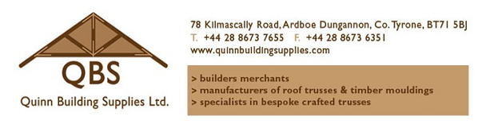
Truss Enquiry Form

Customer: ______________________ Date: ___ / ___ / ___
Address: _______________________
_______________________________
_______________________________
Telephone No: __________________
Fax No: ________________________
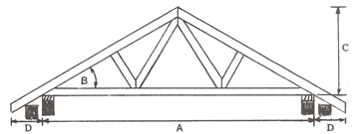

Please check all dimensions, numbers, etc. of all the trusses listed below and sign, returning this form to us as soon as possible.
Orders for trusses cannot be accepted until a signed copy is received.
It is your responsibility to ensure details are correct.
If matching into existing roof check depths of rafters _______ mm.
Number of chimneys or openings _________ and sizes ___________.
No. of Trusses
Span out to of Wallplate (A)
Pitch (B) or Rise (C)
Overhang (D)
Truss Centres
Type of Tile or Slate
Water Tank (Y/N) and Size
Treated (Y/N)
We recommend trusses to be treated
Price delivered to site + V.A.T.

Delivery of trusses to site usually requires use of one of our larger lorries. If we cannot access the site we will leave the trusses at the nearest possible location.
Is there access for 40ft articulated lorry? Yes No
If you are unsure whether or not site access is sufficient, please mention this with you enquiry and we will try to arrange a site visit by one of our delivery drivers to assess the site.

We, Quinn Building Supplies Ltd, accept no costs for cranes or joiners on site before trusses are delivered.

If the enquiry is being made by a contractor or on behalf of any other party, please provide the following details.

Client Name: _______________________________
Site Address: _______________________________
_______________________________
_______________________________

Client Signature: ______________________________

Telephone No - Home: _________________________
- Work: _________________________

A deposit of 50% must be paid when truss order is placed. Full balance must be paid by cash or credit card when trusses are made, before delivery to site. Cheques will not be accepted for final payment of balance.
Please forward this completed form and if possible house plans, to our truss department using one of the following options:

Email: fearghus.quinn@quinnbuildingsupplies.com
Email: declan.coyle@quinnbuildingsupplies.com
Post: Quinn Building Supplies Ltd.
78 Kilmascally Road
Ardboe
Dungannon
Co. Tyrone
BT71 5AP

